Week 02
Problem Statement:
Many people think about their height in feet and inches, even in some countries that
primarily use the metric system. Write a program that reads a number of feet from the
user, followed by a number of inches. Once these values are read, your program should
compute and display the equivalent number of centimeters.
Hint: One foot is 12 inches. One inch is 2.54 centimeters.
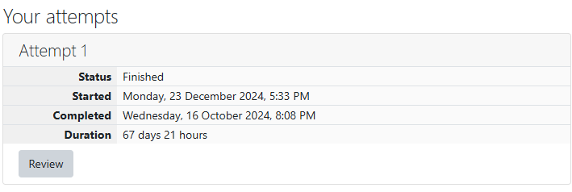
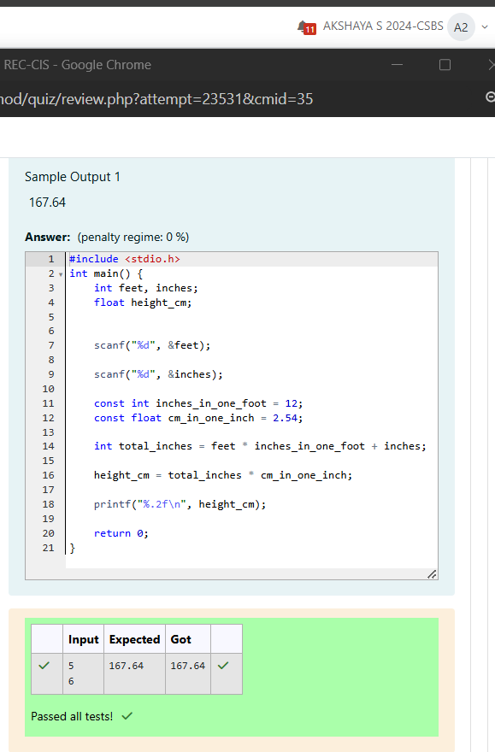
Problem Statement:
Create a program that reads two integers, a and b, from the user. Your program should
compute and display:
• The sum of a and b
• The difference when b is subtracted from a
• The product of a and b
• The quotient when a is divided by b
• The remainder when a is divided by b
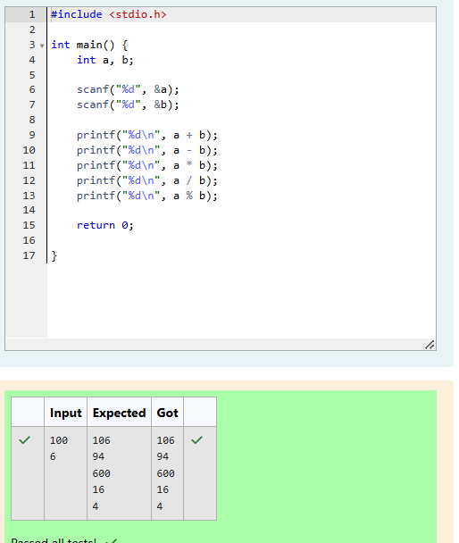
Problem Statement:
A bakery sells loaves of bread for $3.49 each. Day old bread is discounted by 60 percent.
Write a program that begins by reading the number of loaves of day-old bread being
purchased from the user. Then your program should display the regular price for the
bread, the discount because it is a day old, and the total price. Each of these amounts
should be displayed on its own line with an appropriate label. All of the values should be
displayed using two decimal places.
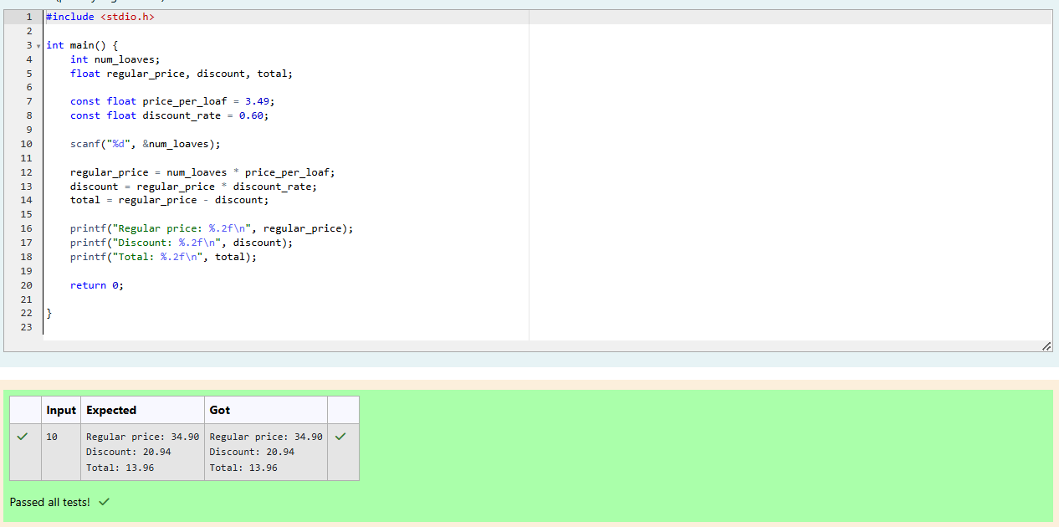
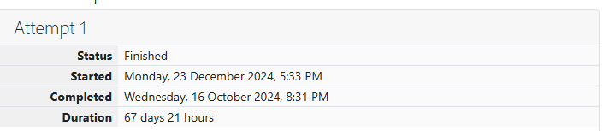
Problem Statement:
Goki recently had a breakup, so he wants to have some more friends in his life. Goki has
N people who he can be friends with, so he decides to choose among them according to
their skills set Yi(1<=i<=n). He wants atleast X skills in his friends.
Help Goki find his friends.
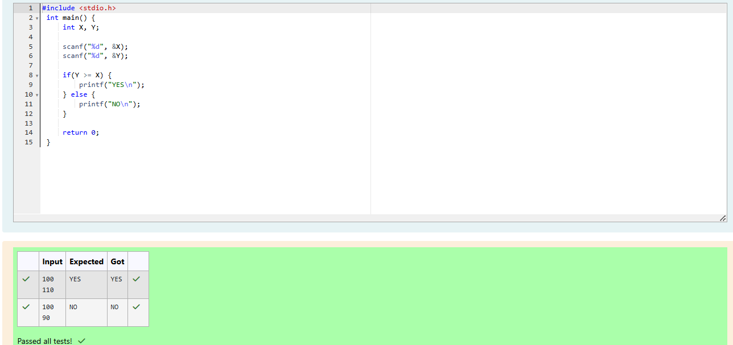
Problem Statement:
Before the outbreak of corona virus to the world, a meeting happened in a room in Wuhan.
A person who attended that meeting had COVID-19 and no one in the room knew about it!
So, everyone started shaking hands with everyone else in the room as a gesture of respect
and after meeting unfortunately everyone got infected! Given the fact that any two persons
shake hand exactly once, can you tell the total count of handshakes happened in that
meeting?
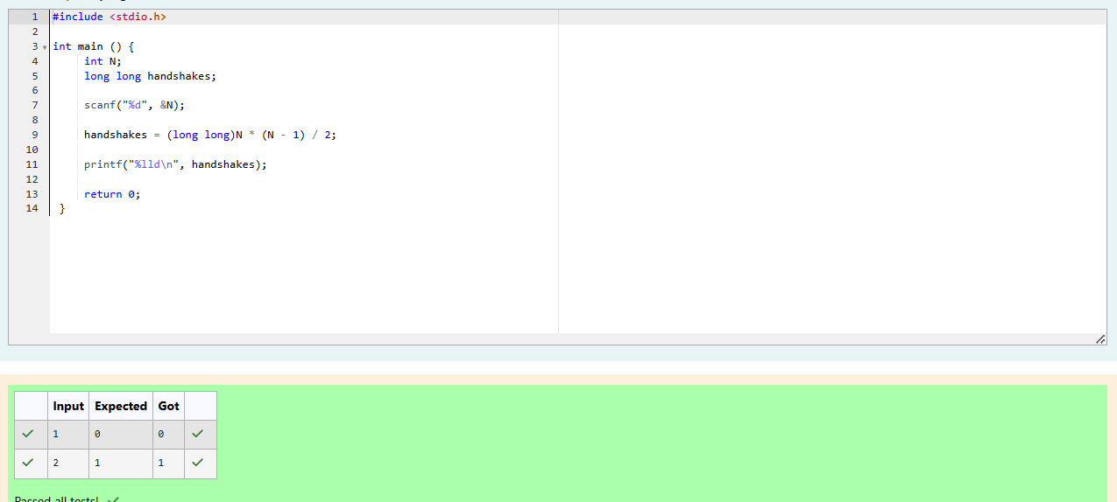
Problem Statement:
In our school days, all of us have enjoyed the Games period. Raghav loves to play cricket
and is Captain of his team. He always wanted to win all cricket matches. But only one last
Games period is left in school now. After that he will pass out from school.
So, this match is very important to him. He does not want to lose it. So he has done a lot of
planning to make sure his teams wins. He is worried about only one opponent - Jatin, who
is very good batsman.
Raghav has figured out 3 types of bowling techniques, that could be most beneficial for
dismissing Jatin. He has given points to each of the 3 techniques.
You need to tell him which is the maximum point value, so that Raghav can select best
technique.
3 numbers are given in input. Output the maximum of these numbers.
